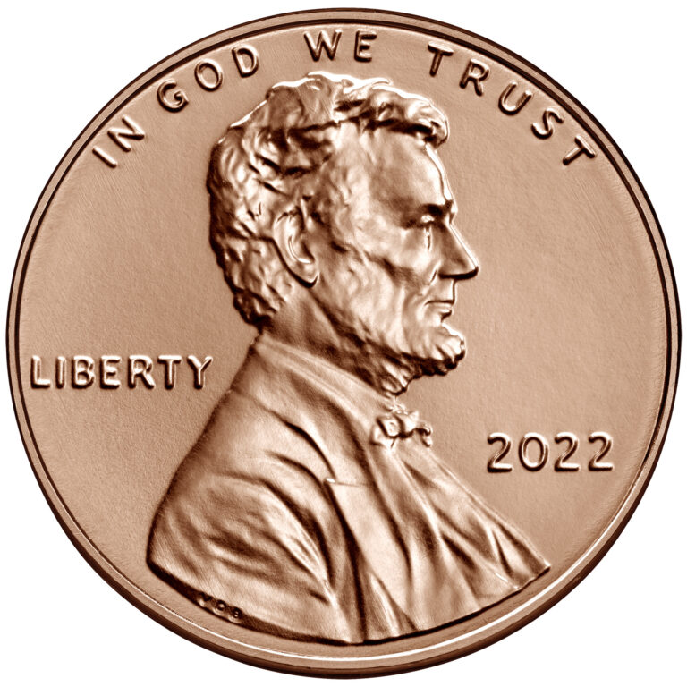
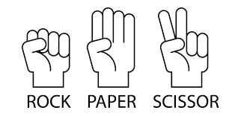
Mind Games: Coin Toss and Rock, Paper, Scissors (RPS)
Can you guess whether a coin toss is heads or tails? Can you win a game of Rock, Paper, Scissors (RPS)? Are these two abilities somehow related?

- Collect class data to fill in the following two-way table.

 | RPS Win | RPS Lose | RPS Tie | Total
Coin Toss Win
Coin Toss Lose
Total

- Suppose that we randomly choose a student from class. Find the following probabilities. Leave answers as fractions (not reduced).

P(Coin Toss Win) = P(Coin Toss Lose) =

P(RPS Win) = P(RPS Lose) = P(RPS Tie) =

P(Coin Toss Win AND RPS Win) = P(Coin Toss Lose AND RPS Win) =

P(Coin Toss Win AND RPS Lose) = P(Coin Toss Lose AND RPS Lose) =

P(Coin Toss Win AND RPS Tie) = P(Coin Toss Lose AND RPS Tie) =

- Suppose that we randomly choose a student from class. Find the following probabilities.

P(RPS Win) =

P(RPS Tie) =

P(RPS Win OR RPS Tie) =

- Suppose that we randomly choose a student from class. Find the following probabilities.

P(Coin Toss Win) =

P(RPS Win) =

P(Coin Toss Win OR RPS Win) =

