How Much Do Fans Love Justin Timberlake? Day 2

In the next city, Justin Timberlake’s concert promoter again wants to find out how much fans enjoy his concerts. He will ask fans, “From 1 to 100, where 100 is the most, how much did you enjoy the concert?” Again, he wants to take a sample of 10 fans. He also would like to try out a couple of new methods for sampling.

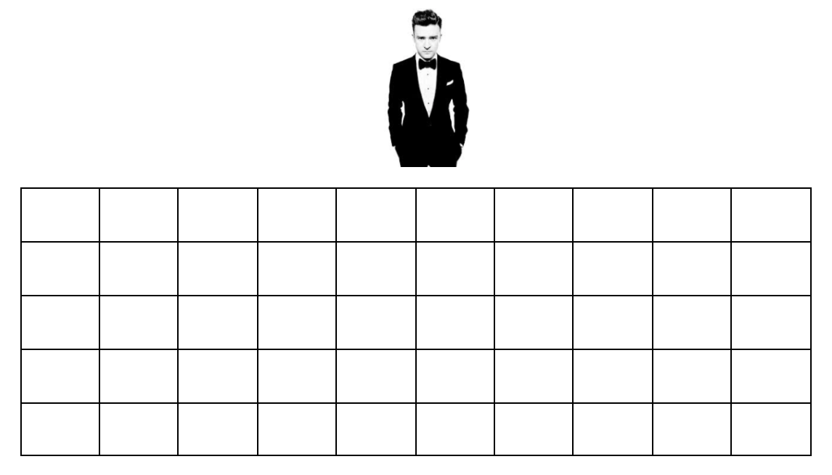
- Method #1:
Take a simple random sample (SRS) of 10
fans.

- Method #2:
To make it easier to distribute the surveys, the promoter decides to pick one row and just sample every fan in that row.

  - Use this method to select a sample of 10 fans.

  - Do you think this method will produce good estimates? Why or why not?

- Method #3:
Justin’s manager thinks it is important to sample fans that have different views of the stage. He wants to sample every 8th fan.

  - First, we need to figure out the starting fan. Randomly select a fan and mark with an X.

  - Begin marking every 8th seat until you get a sample of 10 seats (start back at the beginning if you need to).

- Which method do you think is best? Why?

- Now, it’s time for the actual data. For each of your samples on the previous page, calculate the average enjoyment. Add your average to the dotplots on the board.
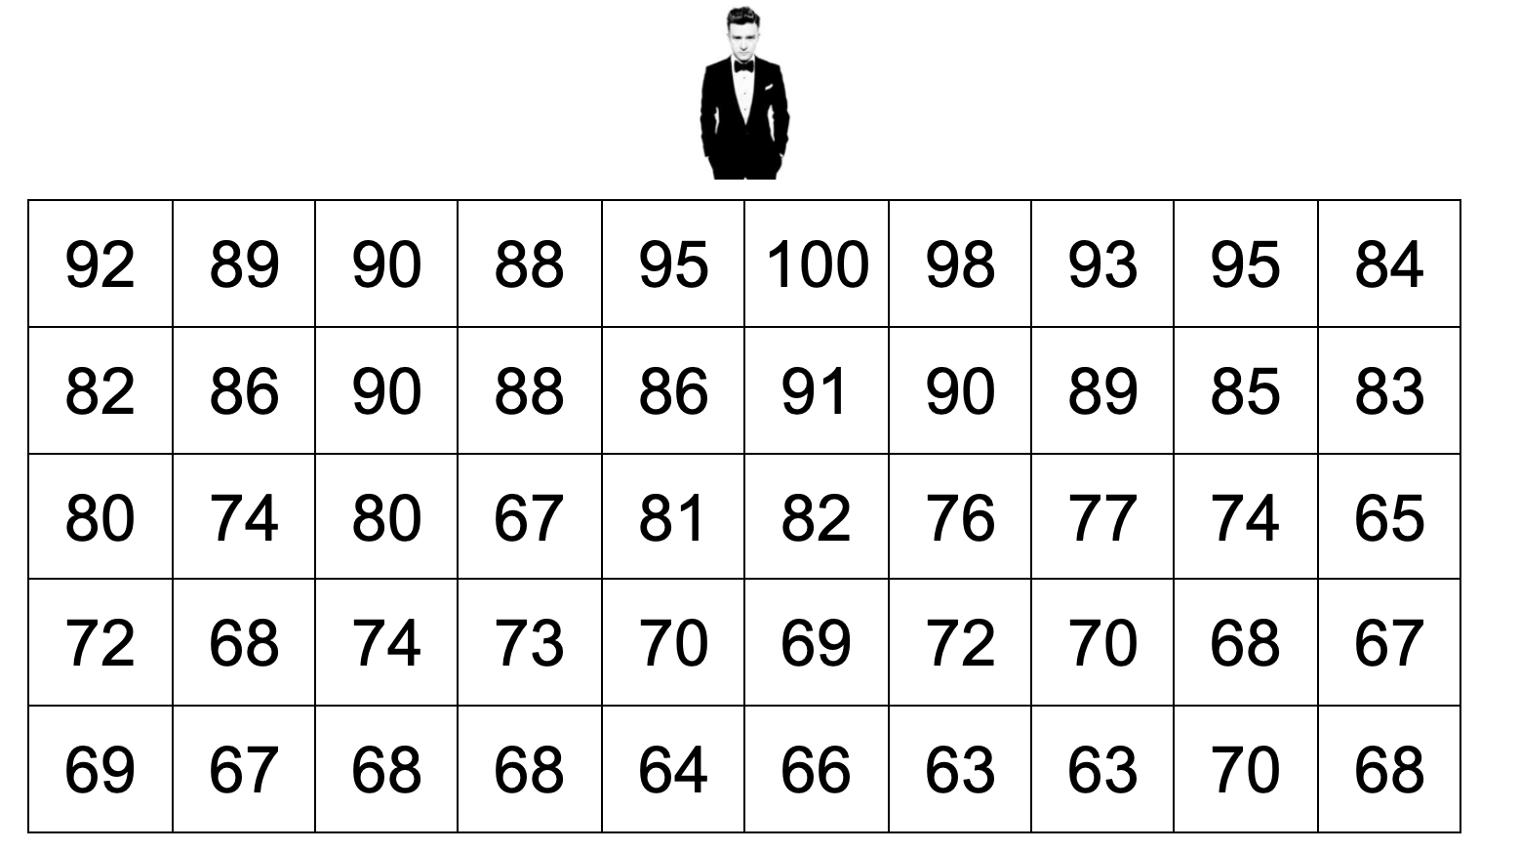
Sample #1:

Sample #2:

Sample #3:

Method #1: SRS

average enjoyment

Method #2: Cluster Sample

average enjoyment

Method #3: Systematic Random Sample

average enjoyment

More Sampling Methods Day 2
Important Ideas:
Check Your Understanding:

The manager of a large ocean front hotel would like to survey their guests to determine their satisfaction with the view from their room. The hotel has 10 floors. Half of the rooms overlook the ocean and the other half overlook the street. There are 50 rooms on each floor, for a total of 500 rooms. The hotel manager would like to select a sample of 50 rooms.

- Describe how to select a stratified random sample of 50 rooms.

- Describe how to select a cluster sample of 50 rooms.

- Describe how to select a systematic random sample of 50 rooms.

- Explain a benefit of using each of the three types of sampling methods in this context.

