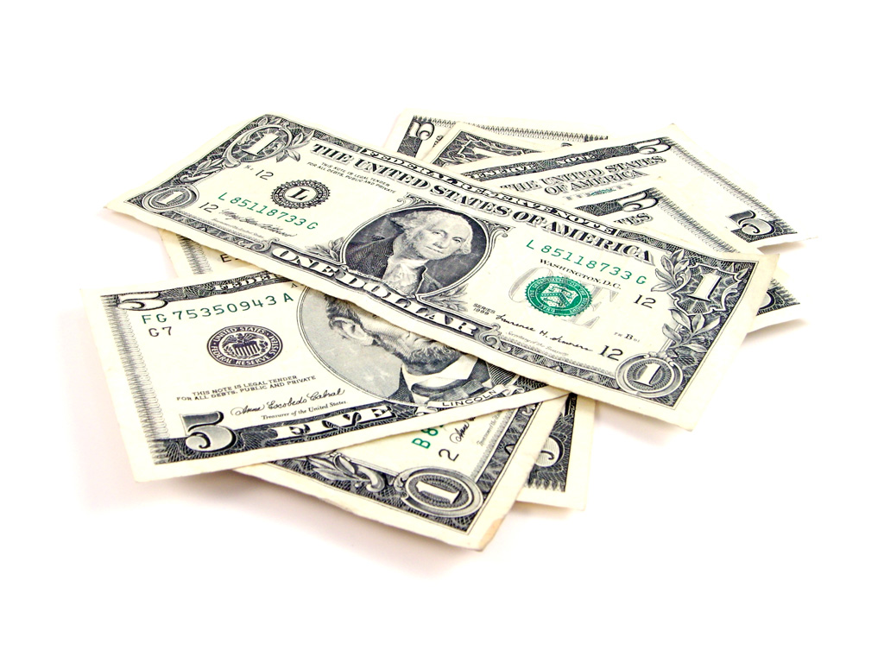 **How much will you make next year?**

After much thought Mrs. Gallas has finally decided on permanent employee wages which are randomly assigned using the probability distribution *X* given below*.* Additionally, at the end of every year she gives her employees an hourly raise. The bonuses are assigned randomly according to the probability distribution *Y* given below. Assume *X* and *Y* are independent.

1. Find the mean, variance and standard deviation of the probability distribution of *X*, the hourly wages.

|  |  |  |  |
| --- | --- | --- | --- |
| *X* | 9 | 12 | 15 |
| Probability | 0.30 | 0.45 | 0.25 |

Mean: Variance: Standard Deviation:

1. Find the mean, variance and standard deviation of the probability distribution of *Y*, the annual hourly raise.

|  |  |  |
| --- | --- | --- |
| *Y* | $1 | $3 |
| Probability | 0.70 | 0.30 |

Mean: Variance: Standard Deviation:

1. Let *N* = the new hourly wage for the upcoming year (*X* + *Y*).

1. What are all the possible new hourly wages for the new year?
2. What is the probability of an employee being assigned a $9 wage **AND** a $1 raise? Show your work.
3. Complete the table below for the probability distribution of *N* = *X* + *Y* and find the mean and standard deviation.

|  |  |  |  |  |  |  |
| --- | --- | --- | --- | --- | --- | --- |
| *N* |  |  |  |  |  |  |
| Probability |  |  |  |  |  |  |

Mean: Variance: Standard Deviation:

1. If *N* = *X* + *Y*, complete the following in terms of *X* and *Y*:

Combining Probability Distributions

Important ideas:

**Check Your Understanding**

Mrs. Chauvet recently had twins. Let *X* = the number of diaper changes per day for Alyse and *Y* = the number of diaper changes per day for Jocelyn. Based on a few weeks of careful records, the probability distributions of *X* and *Y* are as follows:

|  |  |  |  |  |  |  |  |  |  |  |
| --- | --- | --- | --- | --- | --- | --- | --- | --- | --- | --- |
| Number of diapers changed *xi* | 3 | 4 | 5 | 6 |  | Number of diapers changed *yi* | 3 | 4 | 5 | 6 |
| Probability *pi* | 0.05 | 0.25 | 0.75 | 0.10 |  | Probability *pi* | 0.05 | 0.20 | 0.55 | 0.20 |

Mean:  = 5.5 SD: = 1.043 Mean:  = 4.9 SD: = 0.768

Define *T* = *X* + *Y*. Assume that *X* and *Y* are independent.

1. Find and interpret .
2. Calculate and interpret .
3. Alyse wears Diaper size 1, which cost $0.238 per diaper and Jocelyn wears Diaper size 2 which cost $0.2975 per diaper. Find the mean and standard deviation of Mrs. Chauvet’s total diaper cost per day.