Does seat location matter? Part 1
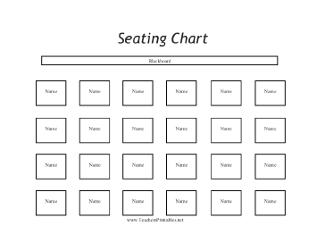
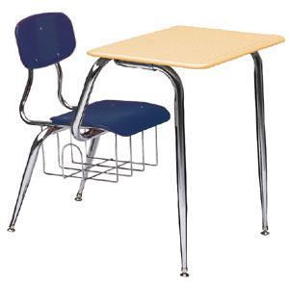

Do students who sit in the front rows do better than students who sit farther away?

Row | 1 | 1 | 1 | 1 | 1 | 1 | 2 | 2 | 2 | 2 | 2 | 2 | 3 | 3 | 3 | 3 | 3 | 3
Score | 76 | 77 | 94 | 99 | 88 | 90 | 83 | 85 | 74 | 79 | 77 | 79 | 90 | 88 | 68 | 78 | 83 | 79
Row | 4 | 4 | 4 | 4 | 4 | 4 | 5 | 5 | 5 | 5 | 5 | 5
Score | 94 | 72 | 101 | 70 | 63 | 76 | 76 | 65 | 67 | 96 | 79 | 96

- Is this an observational study or an experiment? Why?

2. Why is it important to randomly assign the students to seats rather than letting each student choose his or her own seat?

3. How many variables are we measuring?_____ Are they categorical or quantitative?_____________

What is the explanatory variable (x)?__________________ Response variable(y)?_____________

4. Use stapplet.com to make a scatterplot. Sketch it below.

5. Find the least squares regression line (LSRL):__________________________________________

6. What is the slope of the LSRL:_________ Interpret the slope in the context of the problem.

Does the negative slope provide convincing evidence that sitting closer causes higher achievement, or is it plausible that the association is purely by chance because of random assignment?

In order to answer this question, we need to know more about “purely by chance because of random assignment”. If we assume that seat location has NO effect on Exam Score, then we could just randomly assign all 30 Exam Scores to each of the seat locations. We will do this by writing down each of the 30 Exam Scores onto an index card, shuffle the index cards, and then randomly assign them to seat locations.

In pairs, shuffle up the note cards and randomly assign 6 students into each of the 5 rows. Record the results:

Row 1: _____, _____, _____, _____, _____, _____
Row 2: _____, _____, _____, _____, _____, _____
Row 3: _____, _____, _____, _____, _____, _____
Row 4: _____, _____, _____, _____, _____, _____
Row 5: _____, _____, _____, _____, _____, _____ Now find the slope of the LSRL:____________

Repeat this process 2 more times for a total of 3 different samples. Record the results.

Row 1: _____, _____, _____, _____, _____, _____
Row 2: _____, _____, _____, _____, _____, _____
Row 3: _____, _____, _____, _____, _____, _____
Row 4: _____, _____, _____, _____, _____, _____
Row 5: _____, _____, _____, _____, _____, _____ Now find the slope of the LSRL:____________

Row 1: _____, _____, _____, _____, _____, _____
Row 2: _____, _____, _____, _____, _____, _____
Row 3: _____, _____, _____, _____, _____, _____
Row 4: _____, _____, _____, _____, _____, _____
Row 5: _____, _____, _____, _____, _____, _____ Now find the slope of the LSRL:____________

You have now calculated three different possible values for the slope based on random assignment. Take these 3 values to the dotplot on the whiteboard in the front of the room. When everyone in class has recorded their data, copy the dotplot below:

Sampling Distribution of b
Important ideas:

Check Your Understanding
You may have heard that your nose and ears grow through your whole life. While it is true that your nose and ears get bigger throughout life, its not because they grow, but because of gravity. The cartilage in your nose and ears break down as we age and the “growth” people observe is the result of drooping. To quantify the expansion of ears over time, a random sample of 30 adults were selected. For each adult, their age (in years) was recorded and their ear height (cm) was measured. Below is the regression output. Is there evidence of a positive linear relationship between age and ear height? Assume the conditions for inference are met.

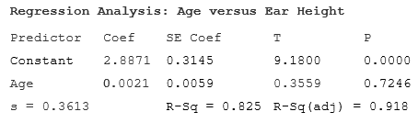
- What is the estimate for α? Interpret this value.

- What is the estimate for β? Interpret this value.

- What is the estimate for σ? Interpret this value.

- Give the standard error of the slope SE_{b}. Interpret this value.

