What will be the EK mascot?
When the high school was built in 1969, the school needed to pick a mascot. The principal decided to have the students and teachers vote between three choices: rams, falcons, or prairie dogs. He took a random sample of students and a random sample of teachers. The results of the surveys are given in the table.

 | Rams | Falcons | Prairie Dogs
Teachers | 80% | 10% | 10%
Students | 30% | 60% | 10%

- Create two bar graphs below to display the results. Use three different colors for the bars.

- Complete the third graph by taking each bar from the teacher sample and stacking them. Use the colors to mark each section. Do the same for the student sample.
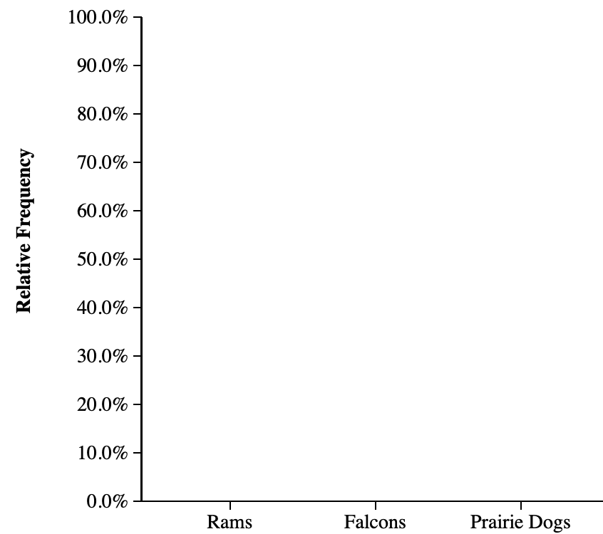
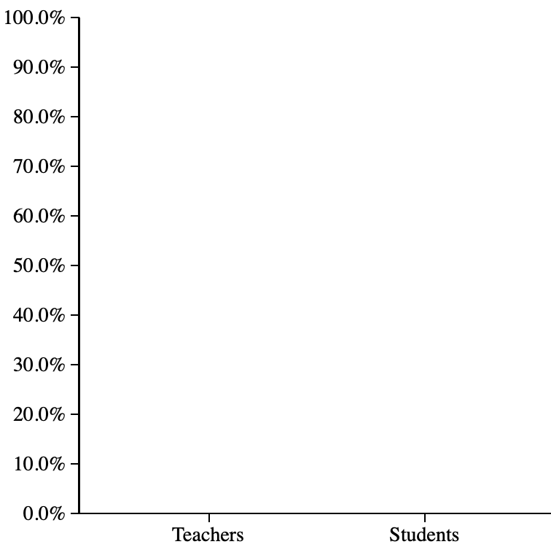
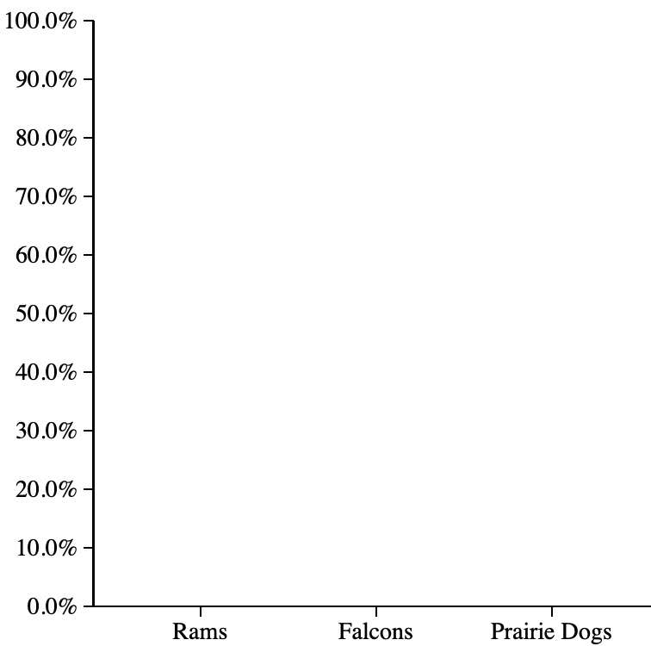
Teachers Students

- According to your displays, which mascot appears to have the most support? Explain.

- Upon hearing the results of the surveys, the students argued that the decision was incorrect because 100 teachers had been surveyed and 500 students had been surveyed. Use this information to fill in the table below with the number of responses.

 | Rams | Falcons | Prairie Dogs
Teachers
Students

- How many times more students were sampled than teachers? _____. How can you update the third graph in #1 to take into account the sample size? Adjust your graph.

- What should they make the EK mascot? Explain.
Representing Two Categorical Variables
Important Ideas:
Check Your Understanding:

The following table gives the result of a random sample of upper level students at Rocky Vista University (the Fighting Prairie Dogs!), along with a mosaic plot.

 | Grade Level
Employment Status | Junior | Senior
Currently working | 14 | 30
Not working but have had a job | 22 | 40
Never had a job | 15 | 10

- Calculate the proportion of Juniors that are currently working, not working but have had a job, and never had a job.

- Calculate the proportion of Seniors that are currently working, not working but have had a job, and never had a job.

- Write a few sentences summarizing what the display in part (a) reveals about the association between grade level and job experience for the students in the sample.

