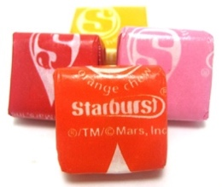
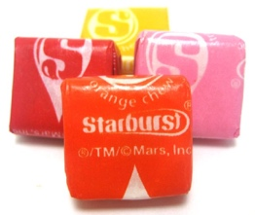
Matching Starbursts
The game is simple. Reach your hand into the bag and choose a Starburst. Replace the Starburst into the bag, mix up the bag, then reach in for another. If the color matches the first one, you win!
What is the probability of winning this game?

- Your group should play the game 10 times total.
- Number of wins for the group =
- Based on the results from your group, what is the probability of winning this game?
- Let’s see what happened in the other groups. Record your number of wins at the front of the room.
- Number of wins for the class =
- Based on the results from your whole class, what is the probability of winning this game?
- How could we improve this estimate of the probability of winning?

2nd candy

R, R
- To determine the true probability of winning, we can list out all possible pairs of choices that we could get. Complete the table.
1st candy

- Complete the following:

- Circle the outcomes with both red. What is the probability of winning with two red?

- Circle the outcome with both yellow. What is the probability of winning with two yellow?

- Overall, what is the probability of winning?

Simulation and Sample Space BATS
- Give a probability model for a random chance process with equally likely outcomes and use it to find the probability of an event.
Use basic probability rules, including the addition rule for mutually exclusive events and the multiplication rule for independent events.
BAT #1 – Probability Model  List / diagram showing all possible outcomes ( ) | BAT #2 – Basic Probability Rules

