Can You Taco Tongue and Evil Eyebrow? Day 2

Are the events “Yes Taco Tongue” and “Yes Evil Eyebrow” independent?

- Find class data from the previous lesson and fill in the following two-way table.

 | Yes  Evil Eyebrow | No  Evil Eyebrow | Total
Yes Taco Tongue
No Taco Tongue
Total

Suppose we randomly choose a student from class.

- Find P(Yes Taco Tongue OR Yes Evil Eyebrow)

- Given that the person selected is a Yes Evil Eyebrow, what is the probability that they are a Yes Taco Tongue? Write as a fraction, a decimal, and a percent.

- Given that the person selected is a No Evil Eyebrow, what is the probability that they are a Yes Taco Tongue? Write as a fraction, a decimal, and a percent.

Definition: Two events are independent if knowing whether or not one event has occurred does not change the probability that the other event will occur.

- Are the events “Yes Taco Tongue” and “Yes Evil Eyebrow” independent? Explain.

Consider the data for all Seniors at EKHS.
 | Yes  Evil Eyebrow | No  Evil Eyebrow | Total
Yes Taco Tongue | 180 | 300 | 480
No Taco Tongue | 20 | 100 | 120
Total | 200 | 400 | 600

- Find each of the following using the data in the table. Write as a fraction, a decimal, and a percent.

- P(Yes Taco Tongue) =

- P(Yes Taco Tongue | Yes Evil Eyebrow) =

- P(Yes Taco Tongue | No Evil Eyebrow) =

- Are “Yes Taco Tongue” and “Yes Evil Eyebrow” independent?

- Fill in the table as if the events were INDEPENDENT.

 | Yes  Evil Eyebrow | No  Evil Eyebrow | Total
Yes Taco Tongue |  |  | 480
No Taco Tongue |  |  | 120
Total | 200 | 400 | 600

- Find each of the following using the INDEPENDENT table. Write as a fraction, a decimal, and a percent.

- P(Yes Taco Tongue) =

- P(Yes Taco Tongue | Yes Evil Eyebrow) =

c. P(Yes Taco Tongue | No Evil Eyebrow) =

- What do you notice about your answers in #6 and #8?

- Generalize: Complete the following statement using a formula.

Let A Yes Taco Tongue and B Yes Evil Eyebrow

If events A and B are INDEPENDENT then…
Conditional Probability and Independence
Important Ideas:
Check Your Understanding:
Yellowstone National Park surveyed a random sample of 1526 winter visitors to the park. They asked each person whether he or she owned, rented, or had never used a snowmobile. Respondents were also asked whether they belonged to an environmental organization (like the Sierra Club). The two way table summarizes the survey responses.

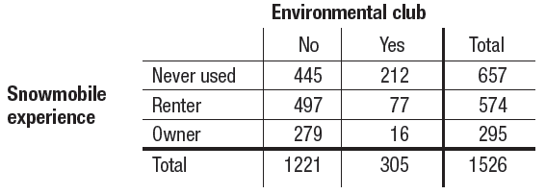

Suppose we randomly select one of the survey respondents. Define events E: environmental club member, S: snowmobile owner, and N: never used.

- Find P(N | E). Interpret this value in context.

- Given that the chosen person is not a snowmobile owner, what’s the probability that she or he is an environmental club member? Write your answer as a probability statement using correct symbols for the events.

- Are the events “Snowmobile owner” and “Environmental club member” independent? Explain.

