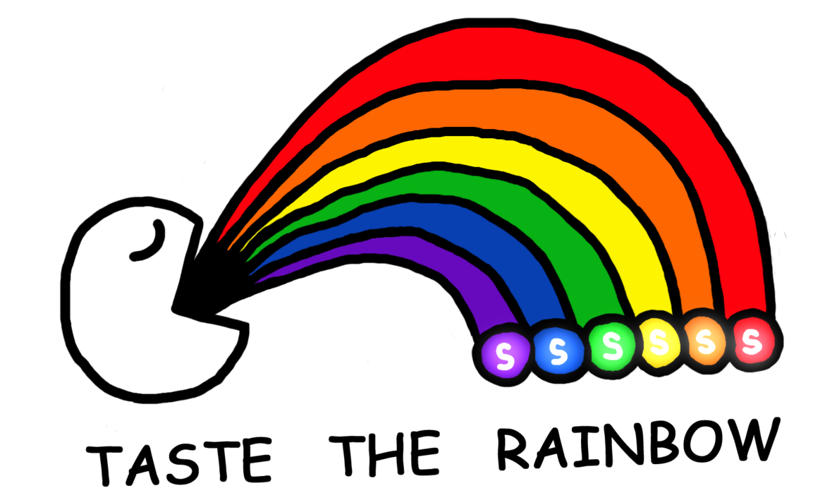
Can You Taste the Rainbow?

Many students claim that they can taste the different colors of Skittles. Today we will conduct an experiment to see if students really can “taste the rainbow”.

Working in groups, your team will attempt to “taste” the flavor for a sample of 50 Skittles.

Collect data: Number correct: ______ Total: ______ Proportion correct: ______

1. Do your data provide some evidence that your group can taste the rainbow? Why?

Mrs. Gallas tried to taste the rainbow for a sample of 50 Skittles and correctly identified the flavor for 14 of the Skittles (). While these results do provide some evidence that Mrs. Gallas can taste the rainbow (0.28 > 0.20), let’s investigate the possibility that she got these results simply by “guessing” the rainbow.

2. Recall the previous “Guess the Rainbow” activity. Copy the dotplot that showed the distribution of proportion correct obtained by guessing.

Proportion correct

Shape: Center: Variability:

3. Assuming Mrs. Gallas was simply “guessing”, how likely is it that she would get 14 or more correct out of 50?

4. Do we have convincing evidence that Mrs. Gallas can “Taste the Rainbow”? Explain.

