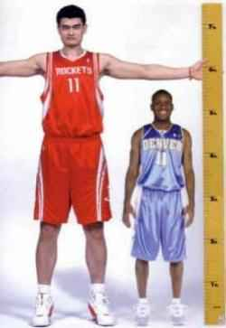
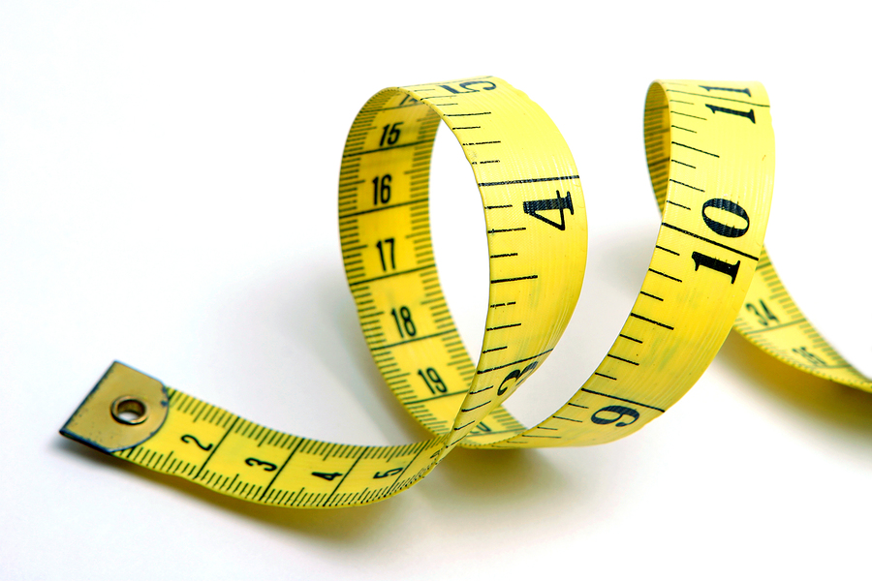
Where do I stand?

How does my height compare with other AP Stats students?

The dotplot below represents a random sample of the heights of 20 AP Stats students to the nearest inch.
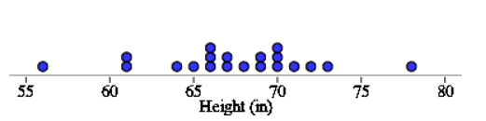
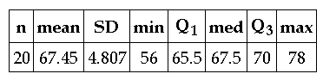

- Describe the distribution.

- a. Arianna is 65 inches tall. What percent of the heights are less than or equal to 65?

b. What is your height? What percent of the heights are less than or equal to your height?

Height | Frequency | Relative Frequency | Cumulative Relative Freq.
56-60
61-65
66-70
71-75
76-80
- Complete the table.

- Use the info in the table to create a cumulative relative frequency graph.
- Mrs. Gallas is 66 inches tall. Estimate and interpret the percentile she is at using the graph.
Cumulative Relative Frequency

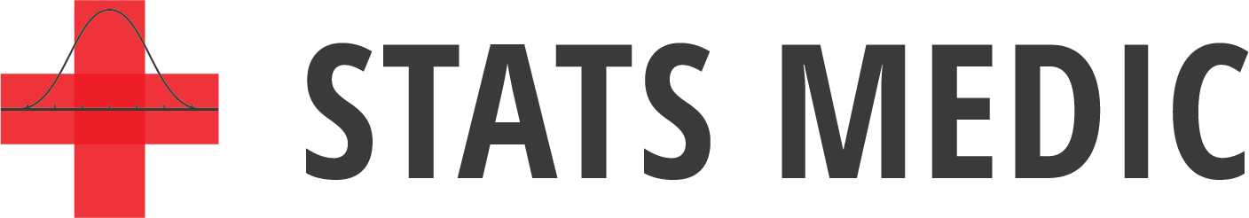
- Estimate and interpret the 80th percentile.
Height (in)
Describing Location in a Distribution
Important Ideas:
Check Your Understanding:

- According to a 2019 article at Insider.com, the state of Pennsylvania was at the 82nd percentile for Pre-K to 12th grade education and was at the 0th percentile for higher education. Explain what these values mean.

- The graph displays the cumulative relative frequency of the cost of in-state public college education for each of the 50 states.

- About what percent of states have in-state public college tuition less than or equal to $8000? More than $8000?

- Estimate Q₁, Q₃, and the IQR of the distribution of phone in-state public tuition.

