How many iPhones will be sold?

Here is the data of all iPhone sales during their opening weekends:
iPhone | Year | Units Sold (millions)
Original | 2007 | 0.5
3G | 2008 | 1
3Gs | 2009 | 1
4 | 2010 | 1.7
4S | 2011 | 4
5 | 2012 | 5
5C, 5S | 2013 | 9
6, 6 Plus | 2014 | 10
6S, 6S Plus | 2015 | 13

- Use stapplet.com to create a scatterplot of the data with year as the explanatory variable and units sold as the response. Sketch the scatterplot in the space above.

- Describe the form of the distribution.

- Use the applet to find the least squares regression line. Write the equation below and graph it on your scatterplot above.

- Use the least squares regression line to calculate the residual for 2007. Interpret the residual.

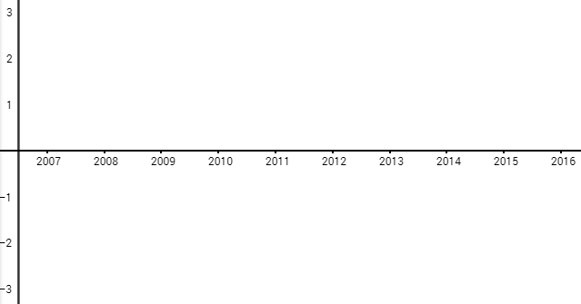
- Complete the table below.
Year | Actual Units Sold (millions) | Predicted Units Sold (millions) | Residual
2007 | 0.5
2008 | 1
2009 | 1
2010 | 1.7
2011 | 4
2012 | 5
2013 | 9
2014 | 10
2015 | 13
- Graph the residuals on the axes below. This is called a residual plot.

- For which points was the actual greater than the predicted? Which were less than predicted? Identify these on the graph.

- Do you think the regression line is a good fit for the data? Why or why not? Explain using the residual plot.
LSRL and Residual Plots
Important Ideas:
Check Your Understanding:
Fueleconomy.gov gives the city and highway fuel economy for all makes and models of vehicles back to 1984. The table gives the city and highway fuel economy (mpg) for a random sample of ten 2021 vehicles.

City fuel economy (mpg) | 14.4 | 24.3 | 27.2 | 29.9 | 20.4 | 28.8 | 20.9 | 23.2 | 28.6 | 25.4
Highway fuel economy (mpg) | 25.5 | 37.4 | 36.5 | 45.5 | 28.7 | 46.1 | 33.6 | 38.3 | 41.3 | 35.3

- Calculate the equation of the least-squares regression line.

- Make a residual plot for the linear model in Question 1.

- What does the residual plot indicate about the appropriateness of the linear model? Explain your answer.

