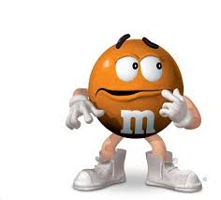
Do Skittles or M&Ms have more orange candies?
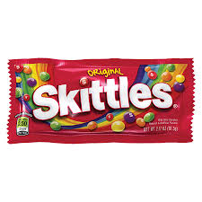

Mr. Wilcox believes that Skittles have a higher proportion of orange candies than M&Ms, while Mrs. Gallas believes the opposite. Who is correct?

- Take an SRS of 50 Skittles and an SRS of 50 M&Ms. Calculate the proportion of orange candies in each sample and find the difference between proportions (Skittles – M&Ms).

Skittles:_______ M&Ms:_______ Difference (Skittles – M&Ms):_______

- Write the difference on a sticker dot and place on the dot plot at the board. Copy the class dot plot below.

Difference between proportions (Skittles – M&Ms)

- What does each dot represent?

- For the dotplot above, make a prediction about the following:

Shape:

Center (mean):

Variability (SD):

A Google search reveals that 21.6% of Skittles are orange and 20% of M&Ms are orange.

- Describe the sampling distribution of the sample proportion of orange for Skittles (X) and the sampling distribution of the sample proportion of orange for M&Ms (Y) for samples of size 50.

 | Skittles (X) | M&Ms (Y)
Shape:
Mean:
SD:

- Describe the sampling distribution of the difference between proportions of orange Skittles and M&Ms (X – Y).

Shape:

Mean of difference between proportions:

Standard deviation of the difference between proportions:

- Mr. Wilcox and Mrs. Gallas calculated a difference between proportions of 0.08 from their samples. Calculate the probability of getting this difference in proportions or higher.

The Sampling Distribution of ${\hat{p}}_{1}-{\hat{p}}_{2}$
Important ideas:

Check Your Understanding
At Westville High School there are 315 seniors and 289 juniors. 65% of the seniors have parking passes and 42% of the juniors have parking passes. The statistics teacher selects a SRS of 30 seniors and a separate SRS of 30 juniors. Let ${\hat{p}}_{S}-{\hat{p}}_{J}$ be the difference in the sample proportions of seniors and juniors that have parking passes.

- What is the shape of the sampling distribution of ${\hat{p}}_{S}-{\hat{p}}_{J}$? Why?

- Find the mean of the sampling distribution.

- Calculate and interpret the standard deviation of the sampling distribution.

- What is the probability that the difference in sample proportions (senior – junior) of students with parking passes is greater than 30%?

