How are your favorite classes related?

Is your favorite elective class associated with your favorite core class? Collect class data to see if there is a relationship.

- Which of the following is your favorite elective class? You must choose only one and mark your choice on the board.

Art | Music | Physical Education | Foreign Language | Technology

- Identify the individuals and variable?

- Is the variable categorical or quantitative?

- Go to stapplet.com to enter the class data. Make a bar graph and a pie chart. Sketch them below.

- Sometimes it is helpful to investigate more than one variable. Come to the board and put a tally mark where you belong.
Find each of the following:
 |  | Core Class
 |  | Math | English
 | Art
 | Music
Elective | P.E.
 | Foreign Lang.
 | Tech.

% of all students who chose P.E.:

% of all students who chose Math and chose Art:

% of the students who prefer math that chose Tech.
- How many variables does the table have? Are the variables categorical or quantitative?

- Which variable would best explain or predict the other variable?

- Go to stapplet.com and enter the data. Make a side-by-side bar graph and a segmented bar graph. Sketch them below.

- How do the bars in the side-by-side-bar graph relate to the bars in the segmented bar graph?

- Is there an association between favorite core subject and favorite elective? If so, describe it.

- If there was not an association between favorite core subject and favorite elective, what would the graphs look like? Explain.

Analyzing Categorical Data
Important Ideas:
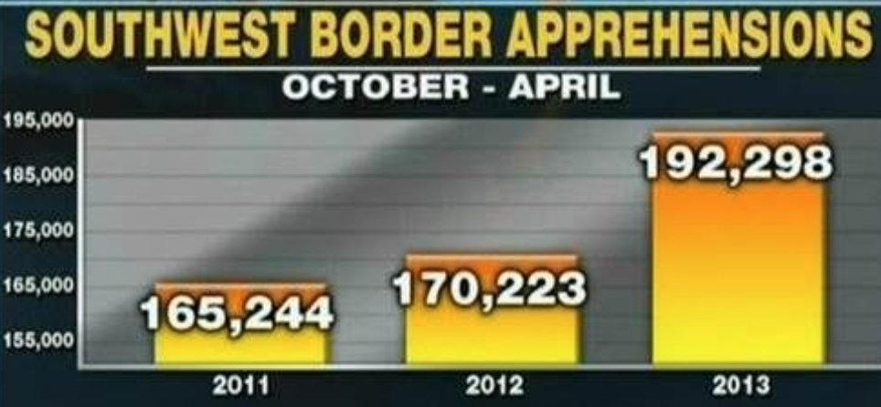
Check Your Understanding:
- The following graph was displayed by a national news organization. Explain why the graph may be misleading, and sketch a corrected version of the graph.

- A real estate agent is collecting data on the number of houses built in his town’s three neighborhoods during three different decades. The table below gives information.
 | 1960s | 1970s | 1980s
Shady Lane | 40 | 30 | 10
Oakcrest | 60 | 15 | 5
Pinewood Estates | 0 | 45 | 15

- What proportion of the houses shown were built in Pinewood Estates?

- Find the distribution of Decade Built for the houses in this town using relative frequencies.

- What percent of homes were built in Oakcrest and in the 1960s?

