2007 AP Statistics Free Response #1 (Modified)

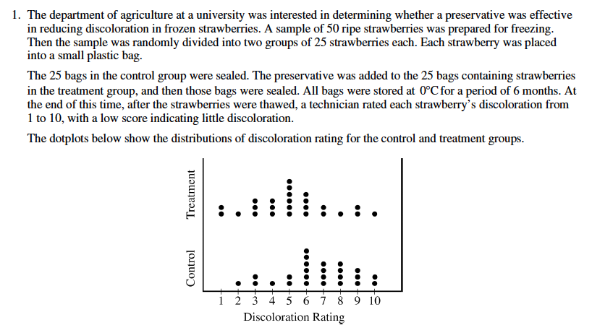

- The median discoloration value in the control group is equal to 7. If a random strawberry is selected from the treatment group, what is the probability that the discoloration value is LESS than 7 ?
- The standard deviation of ratings for the control group is 2.141. Explain how this value summarizes variability in the control group.
- Based on the dotplots, comment on the effectiveness of the preservative in lowering the amount of discoloration in strawberries. (No calculations are necessary.)
- Researchers at the university decided to calculate a 95 percent confidence interval for the difference in mean discoloration rating between strawberries that were not treated with preservative and those that were treated with preservative. State the conditions and confirm they have been met for this confidence interval.
- The confidence interval the researchers obtained was (0.16, 2.72). Based on the confidence interval, comment on whether there would be a difference in the population mean discoloration ratings for the treated and untreated strawberries.

