Should Rockford switch to bottled water?
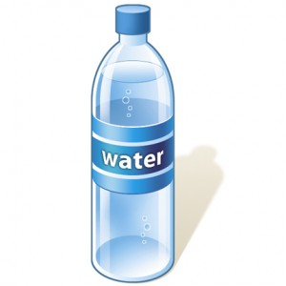
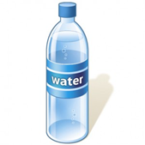

The Wolverine Worldwide (a shoe company in Rockford) improperly disposed of chemicals (PFAS), which have leaked into the ground water. The state of Michigan says that if more than 7% of households in a city exceed the safe limit, the city needs to switch to bottled water. A concerned citizen takes a random sample of 100 households and finds that 12 have unsafe water. Do the data provide convincing evidence that Rockford should switch to bottled water?

- State appropriate hypotheses for performing a significance test. Use .

- (a) After conducting a significance test, a P-value of 0.025 is found. Interpret this value.

(b) Reject H₀ or fail to reject H₀? Keep the current water or switch to bottled water? Explain.

(c) Let’s suppose this decision is wrong. What would be a consequence of this error?

(d) If the water is safe, what is the probability that this error will occur?

- (a) Now suppose the P-value was 0.217. Reject H₀ or fail to reject H₀? Keep the current water or switch to bottled water? Explain.

(b) Let’s suppose this decision is wrong. What would be a consequence of this error?

- Are the consequences in question #2 or question #3 more serious? Explain.

Type I and Type II Errors
Important ideas:

Check Your Understanding
Mr. Wilcox purchased a trick coin that is supposed to land heads up 75% of the time. One of his students volunteer to test this claim. The student flips the coin 50 times and finds that the coin lands heads up 35 times. The student then performs a test of the following hypotheses at the α = 0.10 significance level:
$$H_{0}:p=0.75$$
$$H_{a}:p<0.75$$

where p = the true proportion of tosses of this coin that would land heads-up.

- Describe a Type I error and a Type II error in this setting.

- Which type of error may result in Mr. Wilcox returning the coin and writing a negative review of the product?

- If the student were to use α = 0.05 instead of α = 0.10, would this make it more or less likely to reject the null hypothesis when the null hypothesis is true? Explain.

